**Furniture Ecommerce**

**To do**

* Think of shop name
* Collect data
* Base ERD
  + Products
  + Users
  + Orders

**Possible Project Goals**

* Showcase team members skills
* Build an app that has nice pictures and design so that can attract attention, with good UX
* Make it mobile responsive
* Make use of Stripe API
* Make use of Map API ?

**Possible User Stories**

P1 - High Priority

* User can browse furniture
* User can click and see the details of each furniture
* User can add furniture to cart
* User can check cart, edit and delete items
* User can check out and “pay for” items in cart.
* User should not need to login to browse and add item in cart
* User can login /register
* User can view past orders
* User can see the different category of furniture in the navigation

P2 - Medium High Priority

* User can select option (colour/sizes) and qty of the furniture, e.g. colours, material
* Users can search furniture
* User can filter furniture by price, colour, size, room, type, style, material, delivery date/ stock availability?

P2B - Medium Priority

* User can checkout as guest
* User can see items that are on promotion/sale
* User can select pages if too many items on the page
* User can interact with the funiture’s images
* User can see items that are new arrivals
* User can see items that are out of stock, when is stock ready etc?
* User can get a list of related products based on colours, types, other people’s purchases?
* User can track orders, progress (can use map api?)
* User can specify delivery date
* User can favourite/unfavourite a product

P3 - Low Priority

* Admin can add, edit, delete product
* Admin can track sales of products
* Admin can monitor, add, edit inventory of product
* Users can see the reviews and rating of a product
* Users can rate and give reviews, testimonials
* Users can chat with sales representative online
* Users can save an item to a wishlist (if got favourite then this is not redundant)
* Users can create, edit, delete wishlist

Not sure (these are important to “users” but nvm for proj)

* User can see store location/ showroom information and images
* Users can see photos of other people’s homes who also bought that product
* User can see warranty information
* User can see the shipping and return policy
* User can see the design philosophy and designers

**Inspiration**

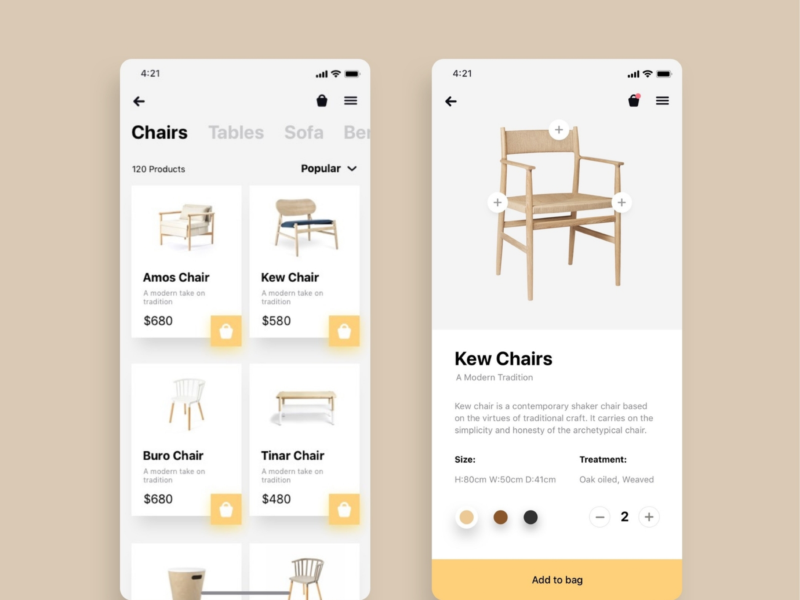

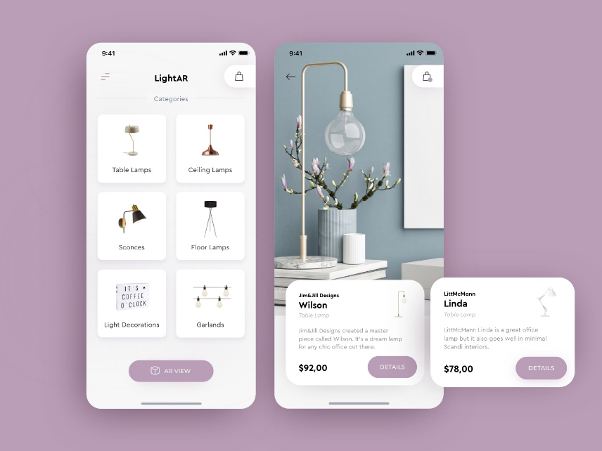

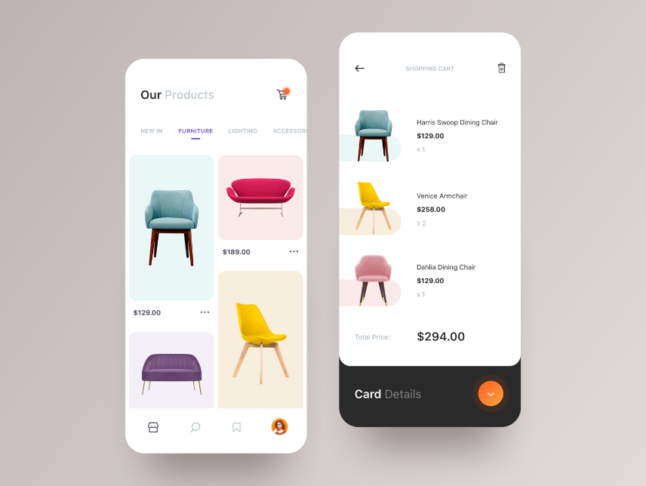

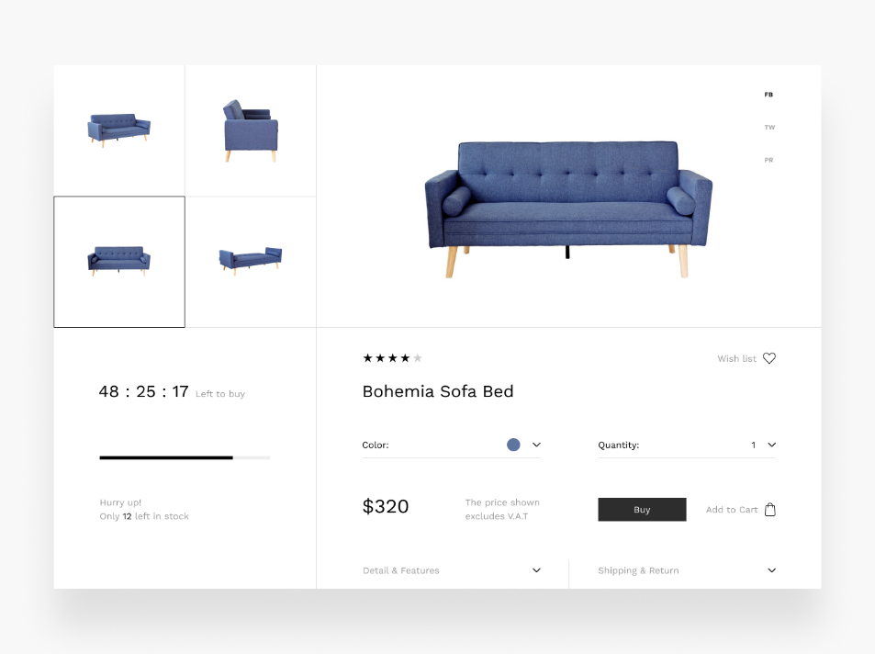

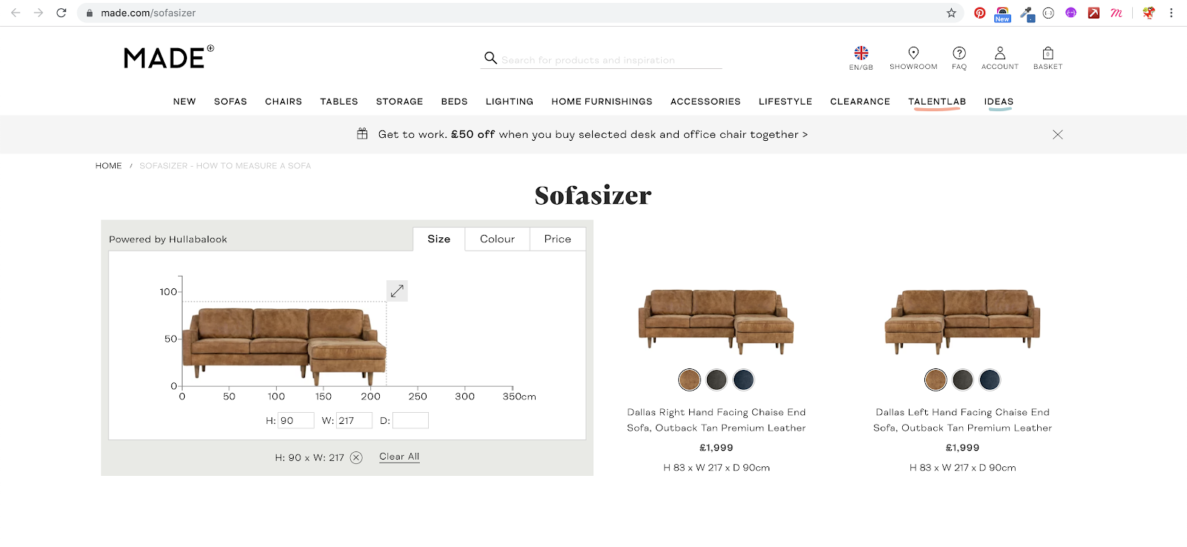

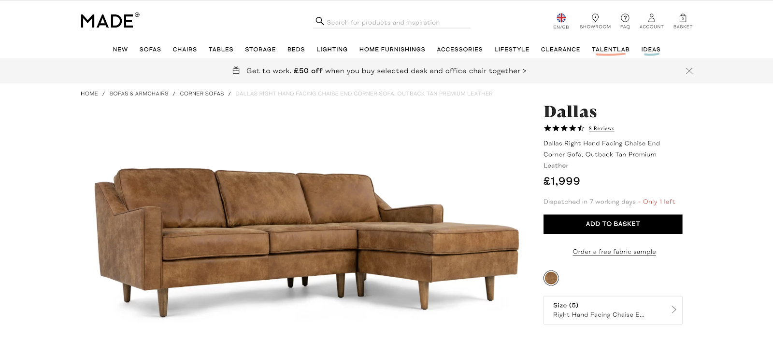

Products

* Name
* Price
* Description
* Category
* Room
* Collection
* Width
* Height
* Length
* Colour
* Material
* (different option, but still must relate them? Need to discuss. Or everything 1 to 1 first.
  + Colour
  + Material (cloth/leather, oak/walnut)
  + Size (3 seater, 2 seater, arm chair, l-shape etc…)
  + Type (e.g. extendable, non extendable)

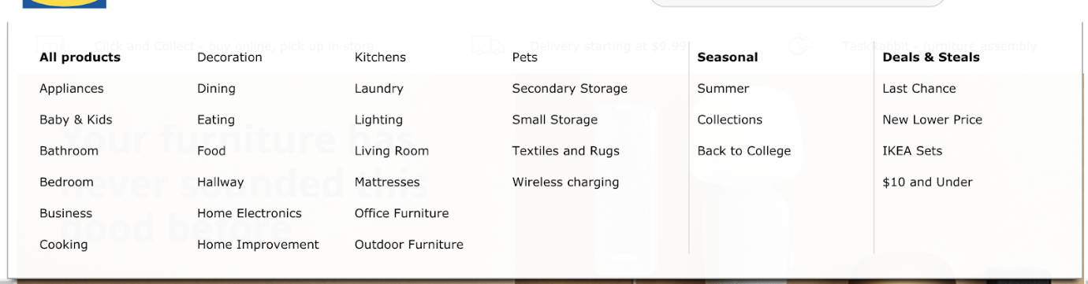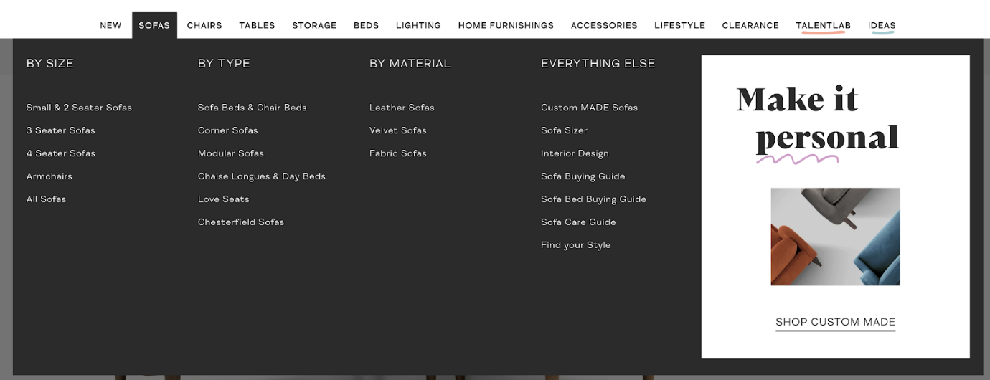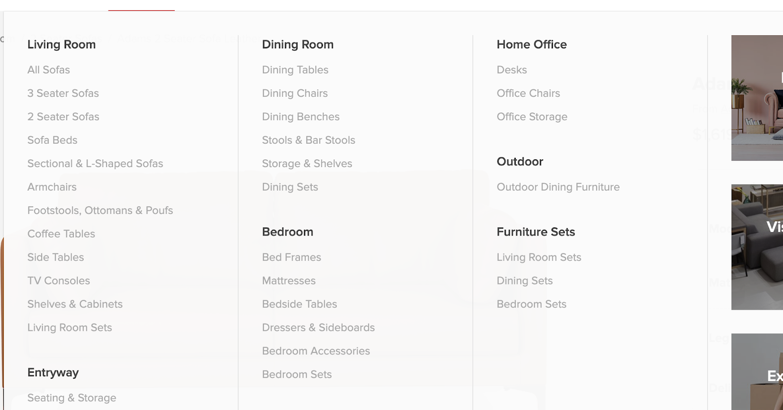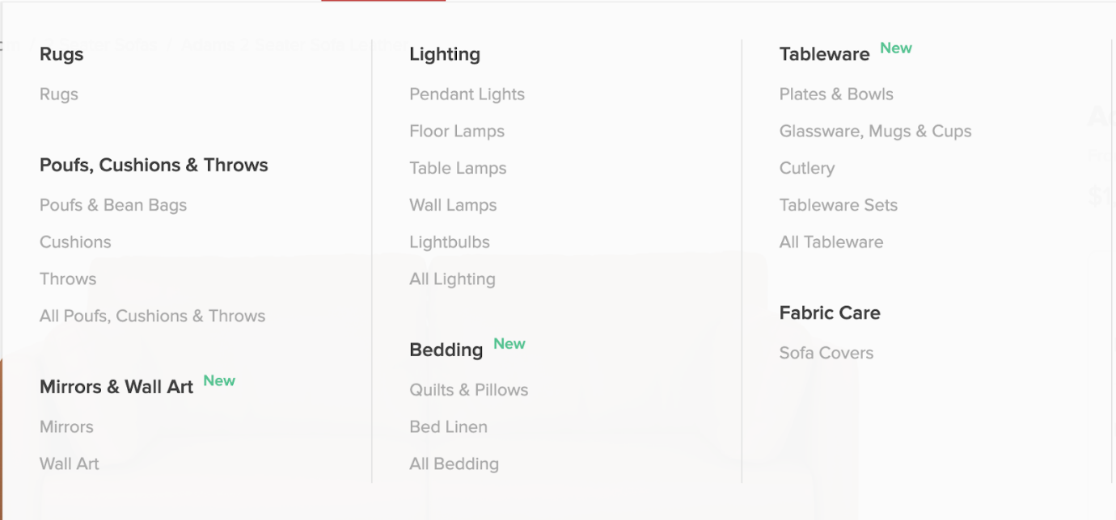

**Functions (More on algo concept)**

**MVP**

* List all furnitures (furnitures RESTful)
* Add furnitures to cart (cart RESTful)
* Users can sign-up and login (Device: users)
* Checkout and pay items in cart placed order, and can view order history (order RESTful (Index/show only) – nested in users, since orders are user-specific. Orders only generated once successful payment)
* Basic sorting by category/alphabetical order (query to furnitures#index)
* Possible table relationships
  + Furnitures/Carts/Orders
    - Furnitures M-M Carts (a carts_furnitures table)
    - Carts M-1 Users (carts table will have user_id,furniture_id, and quantity)
    - Orders M-1 Users (Orders table has user_id)
    - Orders M-M Furnitures (a furnitures_orders table)

(My thought is, Users are specific to 1 cart, users add furnitures into carts, as user checkout and confirm payment, a new order row will be created linking to user_id, and the order will also linked to the furnitures purchased (details passed from carts). Whatever content in the carts then shall be destroyed. If there are items in carts but not purchased, user can still see his last cart items specific to himself only after he logout and login again. Not sure is this ERD relation ok?)

(Adding items into carts without user login can be complicated, need discuss)

**Furthers (Not by priority)**

* Stripe API for purchase
* Admin can add/edit/delete product (RESTful already exists, jz specify only admin can see the add/edit links)
* Mobile responsive
* All the UX Stuff
* Add items into carts AJAX-ly
* add carts_furnitures relationship, and cart number increase without page refresh
* Reviews on furnitures in furnitures#show
* Need a reviews RESTful nested in furnitures, and reviews M-1 furniture relation. And possibly add reviews AJAX-ly, like the “inspirations” assignment
* Select options and qty
* qty column can be added in furnitures_orders table, not sure about options?
* Search system
* Got api?
* New arrivals item
* can set condition for furnitures created_at time and current time if less than 2 days then attach a new arrival sign
* wish list/favorites
* a separate favorites RESTful, M-1 users too. Also let user click favorites AJAX-ly
* maps API
* Not sure where to implement this yet. Location/showroom information or delivery? But if do delivery will be quite a headache